**CHAPTER ONE**

**INTRODUCTION**

**1.1 Background of Study**

In a world where energy conservation and sustainability have become paramount, the quest for innovative and efficient lighting solutions has gained significant momentum. The ever-increasing demand for energy-efficient technologies has spurred the development of sensor-based systems that can intelligently adapt to environmental conditions. This final year project, titled "Design and Construction of a wireless Sensor-Based Lighting System," delves into the intersection of technology and energy efficiency to address the pressing need for smart lighting solutions. The primary objective of this project is to create an intelligent lighting system that leverages advanced sensors to monitor and respond to changes in the surrounding environment. Traditional lighting systems often operate on fixed schedules or user inputs, leading to energy wastage in unoccupied spaces. The proposed wireless sensor-based lighting system aims to overcome these limitations by incorporating state-of-the-art sensors that can detect factors such as motion, ambient light levels, and occupancy. By seamlessly integrating these sensors into the lighting infrastructure, the system will dynamically adjust illumination levels and power consumption based on real-time environmental conditions.

This project not only focuses on the theoretical aspects of sensor technology but also emphasizes the practical implementation and construction of a working prototype. Through meticulous design considerations, the system will be engineered to provide optimal lighting conditions, enhance user comfort, and contribute to significant energy savings. Moreover, the project will explore the potential integration of emerging technologies, such as Wireless sensing, to enable remote monitoring and control of the lighting system. As we embark on this journey of innovation, the project team recognizes the importance of contributing to sustainable practices in the field of computer engineering. The outcomes of this endeavor have the potential to influence future lighting technologies and inspire advancements in smart building infrastructure. By the end of this project, we aim to demonstrate a wireless sensor-based lighting system that not only meets the demands of modern energy-conscious societies but also sets a precedent for intelligent and adaptive lighting solutions.

A well-outlined street lighting system allows road users move around freely in the evening with great visibility, in well-being and comfort and improve the presence of the area. Lighting framework that is inadequately composed can prompt poor visibility which is not useful for any person on foot or driver. Regularly road lighting is ineffectively designed and not appropriately maintained which suggests that there are a substantial number of flawed and dead lights and uses out of date lighting innovation which expends a lot of vitality and monetary assets. Provision of street lighting is a standout amongst the essential duties of a city. wireless sensor-based lighting system is fundamentally utilized as a proficient method for power conservation and maintenance cost. This street lighting system is a vital method for increasing street wellbeing around evening time.

* 1. **Statement of problem**

There are several problems that led to the need for the design of this project. One of which is lack of automation in switching off and on light switches, which can result in lights being left on unnecessarily, leading to increased energy consumption and higher utility costs, apart from that is the increased energy consumption which contributes to a larger carbon footprint, which can be detrimental to the environment another problem that lead to the need for the design of a wireless sensor based lighting system is the Continuous operation of Led at all times even when not necessary can lead to a shorter lifespan for bulbs and other lighting components. Adopting a wireless sensor-based lighting system can address these issues by providing a more intelligent and responsive approach to lighting control, ultimately leading to energy savings, increased efficiency, and improved occupant comfort.

**1.3 Aim and Objectives**

The aim of the project is to Design and Construction a wireless Sensor-Based Lighting Systems to control lighting system of a building or structure it also focuses on creating a system that dynamically adapts to environmental conditions, optimizing energy consumption and enhancing user experience. Through a comprehensive exploration of sensor integration, the project aims to demonstrate the feasibility and practicality of a wireless sensor-based lighting system, contributing to advancements in the field of electrical engineering and sustainable design.

The following objectives to achieve this aim are itemized below:

1. This project seeks to design a wireless sensor-based lighting system that dynamically Toggles between of and on levels based on real-time data from its Transmitter, minimizing energy wastage and enhancing efficiency.
2. Integrate a range of sensors such as motion detectors and occupancy sensors to enable real-time environmental monitoring.
3. Design an algorithm that dynamically switches the state of the relay based on data received from the wireless sensors, optimizing energy efficiency while maintaining user comfort.
4. Implement power-efficient strategies for both the sensor nodes and the overall lighting system, ensuring prolonged battery life and sustainable energy practices.

By addressing these challenges, the project endeavors to contribute to the development of a wireless sensor-based lighting system that not only reduces energy consumption but also provides a sustainable and intelligent solution for the evolving needs of modern lighting infrastructure.

**1.4 Significance of Study**

Wireless sensor-based lighting system holds significant importance due to several advantages & benefits it brings to various aspects of lighting management, energy efficiency, and overall building performance. Wireless sensor-based lighting systems enable intelligent control by toggling the switch of the relay based on occupancy. This leads to significant energy savings by avoiding unnecessary illumination in unoccupied or well-lit areas, Reduced energy consumption directly translates to lower utility costs, making wireless sensor-based lighting systems a cost-effective solution in the long run.

**1.5** **Scope of Study**

1. Designing for optimal energy consumption through intelligent control of lighting based on occupancy and ambient light conditions.
2. Implementing sensors to detect the presence or absence of occupants in a space.

**1.6 Methodology**

The system begins by powering on the microcontroller and sending a start signal to all connected components to it, thereafter it sends a read signal to the PIR module to Detect if a person has entered in to the premises. If the PIR motion sensor returns a high signal to mean that a person has entered the room, trigger the microcontroller to verify in the intensity of light needed in the room, to verify such the microcontroller send a read signal to the LDR module to checks the level of brightness / darkness of the room and calculates the needed amount of light that is needed in that environment leading the system to turn on the lighting system based on the light intensity value returned by the LDR Module.

**CHAPTER TWO**

**LITERATURE REVIEW**

**2.1 Evolution of Lighting System**

The concept of smart lighting can be traced back to the late 1980s and early 1990s when researchers began exploring ways to automate and optimize lighting control. Early systems relied on wired networks and simple occupancy sensors to turn lights on and off based on motion detection.

The evolution of wireless sensor-based lighting systems also traces back to the development of wireless sensor networks (WSNs) and early smart lighting technologies. Initial implementations focused on basic motion sensing and manual control interfaces. However, advancements in wireless communication and sensor technologies have revolutionized these systems. These systems were primarily used in commercial buildings to reduce energy consumption by ensuring lights were only on when needed.(Smith & Brown, 2005). The advent of wireless communication technologies in the early 2000s revolutionized smart lighting systems. Wireless protocols such as Zigbee, Z-Wave, and Wi-Fi enabled more flexible and scalable lighting solutions. These protocols allowed sensors to communicate wirelessly with control units, eliminating the need for extensive wiring and reducing installation costs.(Zigbee Alliance, 2003), In the 2010s, the integration of smart lighting systems with the Internet of Things (IoT) brought a new level of intelligence and connectivity. IoT-enabled smart lighting systems could be controlled remotely via smartphones or centralized management platforms. They also incorporated advanced sensors capable of detecting not only occupancy but also ambient light levels, temperature, and even air quality. This integration allowed for more sophisticated and energy-efficient lighting strategies, such as daylight harvesting and adaptive dimming (Jung & John, 2018).

In recent years, smart lighting systems have continued to advance with the incorporation of machine learning and artificial intelligence. These technologies enable the systems to learn from user behavior and environmental conditions, optimizing lighting settings dynamically. Additionally, advances in energy-harvesting sensors and low-power wireless communication have further improved the sustainability and efficiency of these systems (Guo & Tiller, 2016; Rehman & Loo, 2019).

**Key Milestones**

1. Early Automation Systems: Introduction of basic occupancy sensors for energy saving.
2. Wireless Communication: Adoption of Zigbee, Z-Wave, and Wi-Fi for flexible, scalable lighting solutions.
3. IoT Integration: Enhanced connectivity and control through smartphones and centralized platforms.
4. Machine Learning and AI: Use of advanced algorithms for adaptive and predictive lighting control.
5. Energy Harvesting Sensors: Implementation of energy-efficient sensors for sustainable design.

**2.2 Related Works**

Soyoung Hwang et al. proposed a remote monitoring and controlling system which is based on zigbee networks. Real time monitoring is implemented with JMF. It is a multimedia extension API of java. (Soyoung Hwang and Donghui Yu, 2012)

Richu Sam Alex et al designed and constructed a system which reduced the power consumption of the street lighting system about 30% compared to conventional design. This system is fully automated. It also uses Zigbee so that control station can also analyze all the performances of the system (Richu Sam Alex, R NarcissStarbell, 2014).

Daeho Kim et al. worked on smart LED lighting system by using Infrared and Ultrasonic sensors together. Here they proposed a model which continuously tracks the human motion. Output based on the human tracking data which is obtained by these sensors are responsible for determining the On-Off control of the LED lighting ( Daeho Kim, Junghoon Lee, Yeongmin Jang and Jaesang Cha, 2010).

Previously existing system failed in continuously monitoring the motion of an object by using each sensor separately. For the same reason, the efficiency of the existing system is low. By the hardware implementation they developed a model to improve the efficiency which helps in smart lighting. The proposed approach make use of sensors in which IR sensor sends the sensed data to the MCU board which in turn sends the same data to the LED control layer. Depending on the results of the sensed data LED control layer turns on the lighting system. Human presence is detected by IR sensor and continuous tracking is possible by the Ultrasonic (US) sensor. As before the sensed values are sent to the MCU board by US sensor which controls the On-Off of the lighting. US-IR positioning based system has to be studied in future.

B. K. Subramanyam et al. shave developed a model which provides smart lighting system on streets which is mainly solar based. The people work for late nights and also most of the criminal activities occur during nights (B.K Subramanyam, K Bhaskar Reddy, P. Ajay Kumar Reddy, 2013) Under these situations, to provide security, controlling and monitoring of street light is developed together with GUI. Even the usage of solar panel is helpful for saving the power and money. At the PC side, graphical user interface (GUI) takes part in controlling the street light. For monitoring and controlling the lamps on streets, Zigbee technology is used. More power and energy are saved by using LDR and IS sensors. Basically, this proposed model works on the two operational modes. They are Auto and Manual mode. In Auto mode On-Off of the light are done by using LDRs which measures the intensity of light. Controlling is by use of relays. In the Manual mode, the controlling and monitoring of the street lights is made successful by using the specially designed GUI and by using the Zigbee technology. This proposed system is helpful to provide the street lighting in the rural and urban areas where the traffic is low at times. This system maintains the user satisfaction and is versatile. Raja R et al, (Raja R, Dr.K.Udhayakumar, 2014) worked on the energy saving concepts. Here, smart sensor networks in DC electrical appliances like lighting, helps for monitoring of energy usage. Conventional lamps are powered by AC grid but for LED DC supply is sufficient. Dimming of light can also be achieved by using appropriate protocol helps in energy saving. Replacing the traditional lamp by LED makes 44% energy saving.

Michele Mango et al. proposed a low cost, wireless, adaptable sensor based smart lighting system which makes use of PIR sensors and motion sensors. It is helpful for controlling the light intensity and power consumption using LED light. Dimming of light is achieved using PIR sensor only in presence of obstacles around. Main advantage of this system is energy conservation. In this paper we are planning to propose a system which make use of Pyorelectric Infrared (PIR) sensor, CO2 sensor & Light sensors ( LDR). The dimming of light is achieved using PIR sensor. Intensity measurement and power consumption is measured by using Light sensors. The microcontroller platform used is Arduino uno R3 at sender side and at the receiver end PIC16F877a is used. PIC microcontroller usage helps in linear programming. The intensity, CO2 emission, power consumption comparisons are displayed using LCD display. These sensors are helpful for energy saving. The usage of solar panel further help to save some more power and energy.

**2.3 Wireless Communication Protocols**

Wireless sensor-based lighting systems utilize various communication protocols, including Zigbee, Bluetooth Low Energy (BLE), Wi-Fi, and Z-Wave. These protocols enable reliable communication between sensors, controllers, and lighting fixtures, facilitating seamless integration and interoperability.

* Zigbee Alliance introduced Zigbee, a low-power, low-data-rate wireless protocol suitable for home and building automation applications.
* Bluetooth Low Energy (BLE) emerged as a popular protocol for short-range wireless communication, enabling smartphone-based control and automation.
* Wi-Fi connectivity offers high bandwidth and long-range communication, allowing for cloud-based control and remote monitoring of lighting systems.

**2.4 Sensor Technologies**

Sensors are essential components of wireless sensor-based lighting systems, providing inputs for occupancy detection, ambient light sensing, and environmental monitoring. Key sensor technologies include passive infrared (PIR) sensors, ultrasonic sensors, light sensors, and temperature sensors.

* Passive Infrared (PIR) Sensors: Detect motion by measuring changes in infrared radiation within their field of view.
* Light Sensors: Measure ambient light levels to enable daylight harvesting and adaptive lighting strategies.
* Temperature Sensors: Monitor environmental conditions to optimize lighting performance and energy efficiency.

**2.5 Integration with IoT and Smart Buildings**

The integration of wireless sensor-based lighting systems with the Internet of Things (IoT) and smart building technologies has unlocked new possibilities for energy management, occupant comfort, and operational efficiency.

* IoT Connectivity: Allows for remote monitoring, control, and data analytics of lighting systems, enabling predictive maintenance and energy optimization.
* Smart Building Integration: Wireless sensor-based lighting systems can be integrated with building management systems (BMS) to coordinate with other building functions such as HVAC and security.

**2.6 Previous Implementations of Lighting system**

Numerous real-world implementations demonstrate the effectiveness and benefits of wireless sensor-based lighting systems across various sectors:

1. Commercial Buildings: Implementation of wireless sensor-based lighting systems in offices, retail stores, and educational institutions for energy savings and occupant comfort (Smith, J. & Brown L, 2005).
2. Industrial Facilities: Integration of wireless sensors in manufacturing plants and warehouses for efficient lighting control based on occupancy and activity levels (Johnson, A., & Martinez, B, 2017).
3. Outdoor Lighting: Deployment of wireless sensor-based lighting systems in streetlights and landscape lighting for improved safety, reduced energy waste, and enhanced aesthetics (Kim, S., & Lee, H, 2019).

Wireless sensor-based lighting systems offer significant potential for transforming lighting control in various environments. By leveraging wireless communication, advanced sensors, and IoT integration, these systems provide energy efficiency, flexibility, and intelligent automation. Further research and innovation are necessary to address challenges and fully realize the potential of wireless sensor-based lighting systems in creating sustainable, comfortable, and connected environments.

**2.7 Lighting control**

Lighting control systems play a crucial role in optimizing energy usage, enhancing comfort, and providing the right ambiance in various environments. These systems enable users to manage lighting levels, color, and timing efficiently. Proper lighting control can significantly reduce energy consumption by ensuring lights are only on when and where needed. This is achieved through occupancy sensing, daylight harvesting, and scheduling lighting control also allows for Adjustable lighting levels and color temperature which can create comfortable and productive environments tailored to different activities and preferences, whether it's working, relaxing, or sleeping.

**2.7.1 Components of Lighting Control Systems**

1. **Sensors**: Occupancy sensors, daylight sensors, motion sensors, and light level sensors detect changes in occupancy and ambient light levels, triggering appropriate lighting adjustments.
2. **Controllers**: Centralized or decentralized devices that receive inputs from sensors and send commands to lighting fixtures to adjust brightness, color, and timing.
3. **Switches and Dimmers**: Traditional switches and dimmers are still used for manual control, while smart switches and dimmers enable wireless and remote control via smartphones or voice assistants.
4. **Lighting Fixtures**: Light sources such as LED lamps, fluorescent tubes, and luminaires, often equipped with dimmable or color-tunable features.

**2.7.2 Types of Lighting Control**

1. **Manual Control**: Basic on/off switches and dimmers controlled manually by users.
2. **Automatic Control**: Sensors detect changes in occupancy or ambient light levels and automatically adjust lighting accordingly. Examples include occupancy-based lighting and daylight harvesting.
3. **Programmed Control**: Lighting schedules are pre-programmed to turn lights on/off or adjust brightness/color at specific times.
4. **Smart Control**: Integrated with IoT technology, smart lighting systems allow for remote control, scheduling, and automation via smartphones or voice commands.

**2.7.3 Applications of Lighting Control**

1. **Residential**: Smart lighting systems in homes provide convenience, energy savings, and security through remote control and automation.
2. **Commercial**: Offices, schools, and retail spaces use lighting control to optimize energy usage, enhance comfort, and comply with building codes.
3. **Outdoor**: Street lighting and landscape lighting are often controlled based on time of day, motion, or ambient light levels to improve safety and reduce energy waste.
4. **Hospitality and Entertainment**: Hotels, restaurants, and theaters utilize lighting control to create immersive experiences and set the right ambiance for guests.

**CHAPTER THREE**

**METHODOLOGY**

**3.1 Introduction**

The proposed wireless sensor-based lighting system leverages advanced sensor technology and wireless communication to provide an automated solution for lighting control. The primary components of the system include sensor (motion detectors), microcontrollers for processing sensor data, and wireless modules for communication. By integrating these components, the system can dynamically adjust its lighting system to optimize energy usage.

**3.2 Overview of system**

The system has been divided into two major parts for efficiency in operation, the Detection Unit and the Control Unit which work together to enable the system function as expected.



**Figure 3.1: Block Diagram of Wireless Sensor based lighting system**

**3.3 Design Consideration**

The design process begins with a thorough consideration of the requirements for a wireless sensor-based lighting system for home and office applications. The primary considerations include user convenience, hygienic operation, and the ability to detect occupancy and wirelessly transmit the message. To achieve these objectives, a PIR sensor was chosen for their accuracy in motion and occupancy detection without physical contact. The system is designed to be wireless, allowing sensors to detect the presence of individual and wirelessly control switches and bulbs. The overall design prioritizes simplicity, reliability, and adaptability to diverse home and office setups.

**3.4 Unit of the system**

**Detection Unit:** The detection unit of the smart sensor-based lighting system detects the presence of individual using a three PIR motion sensor that each cover 120 degrees making a total of 360 degrees covered. It does not send any message to the control unit unless motion is detected again, in the case in which motion is detected again it send a motion detected signal to the control circuit using its transmitter (CC1101) set at a frequency of 433.49Mhz to turn on the lighting systems and to remain on for a minute unless a fresh signal is sent again.

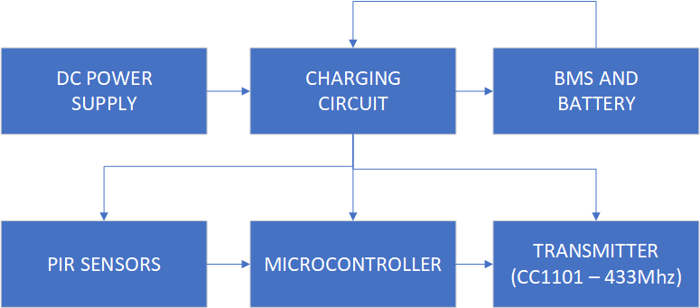

**Figure 3.1: Block Diagram of Detection Unit**

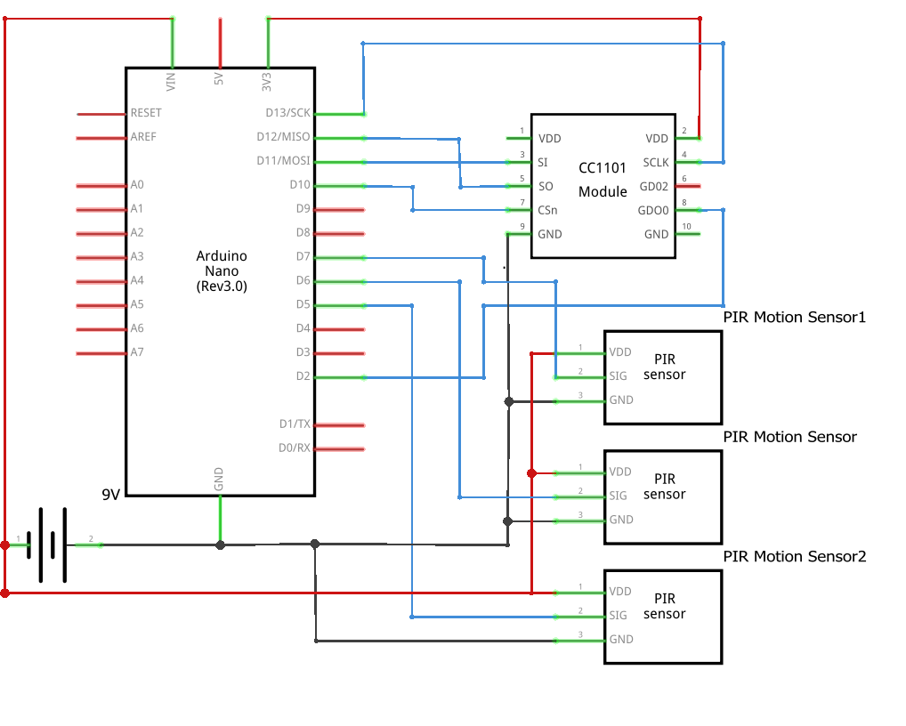

**Figure 3.2: schematic Diagram of Detection / Transmitter Unit**

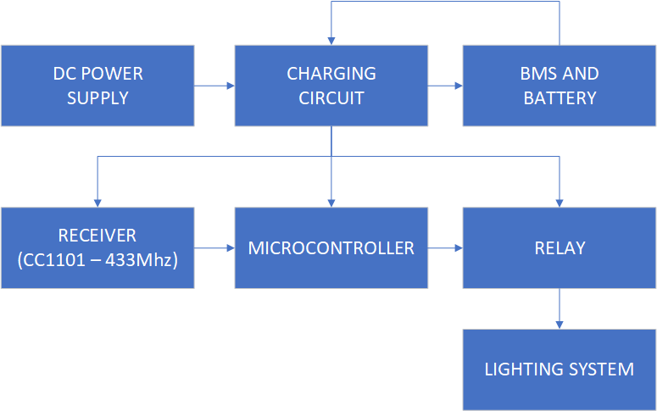**Control Unit:** The detection unit detects the presence of individual using a PIR motion sensor and sends a message to the control unit using a transmitter (CC1101) set at a frequency of 433.49Mhz.

**Figure 3.3: Block Diagram of Control / Receiver Unit**

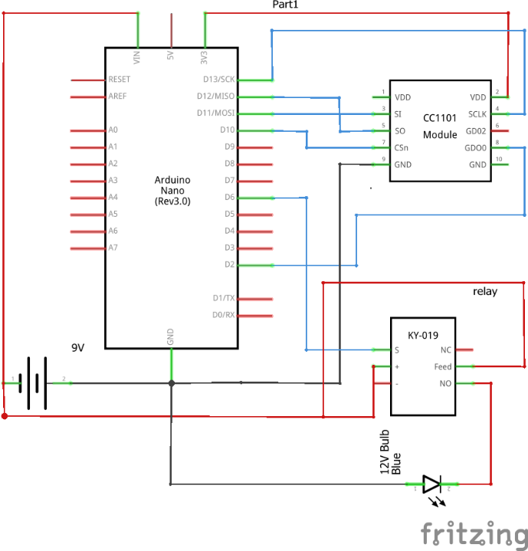**Figure 3.4: Schematic Diagram of Control / Receiver Unit**

**3.3.1 Component Selection**

The selection of components is a critical aspect of the design process, influencing the performance and functionality of the Sensor based lighting system.

**Key components include:**

1. **PIR Sensor Module:** PIR sensors allow you to sense motion, almost always used to detect whether a human has moved in or out of the sensors range. They are small, inexpensive, low-power, easy to use and don't wear out. For that reason, they are commonly found in appliances and gadgets used in homes or businesses. They are often referred to as PIR, "Passive Infrared", "Pyroelectric", or "IR motion" sensors.

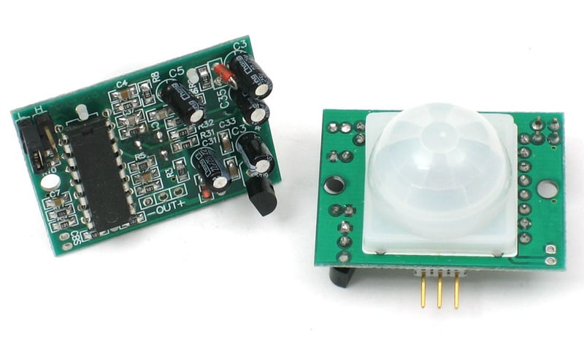

**Figure 3.5: PIR Motion sensor front and back view**

1. **2S BMS:** A 2S BMS is crucial for maintaining the safety and efficiency of battery packs in various applications. By integrating voltage, current, and temperature monitoring with balancing and protection features, a well-designed 2S BMS ensures the longevity and reliable operation of the battery pack.

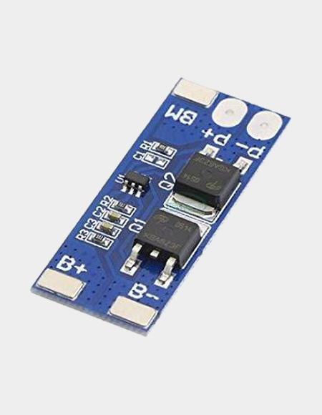

**Figure 3.6: 2s Battery Management System**

1.  **3.7 Lithium Ion Battery:** A 3.7V lithium-ion battery is a type of rechargeable battery commonly used in a wide range of electronic devices due to its high energy density, lightweight, and long cycle life. Two of this such were used for the project having 7.4volts in series and 2000mah of current supply

**Figure 3.7: 3.7 volts** **Lithium Ion Battery**

1. **Arduino Nano and Arduino IDE:** The Arduino Nano, a compact and versatile microcontroller board, has become a cornerstone for hobbyists, educators, and professional engineers alike. Designed around the powerful ATmega328 microcontroller, the Nano packs significant functionality into a small, breadboard-friendly form factor, making it ideal for a wide range of applications from simple DIY projects to complex prototypes. At the heart of the Arduino Nano is the ATmega328, an 8-bit AVR microcontroller renowned for its simplicity, efficiency, and broad adoption. This microcontroller operates at a clock speed of 16 MHz, providing sufficient processing power for numerous tasks while maintaining low power consumption. The ATmega328 features 32 KB of flash memory for storing code, 2 KB of SRAM for dynamic data, and 1 KB of EEPROM for long-term data retention. These memory specifications enable the Nano to handle a variety of applications, from sensor data collection to controlling motors and LEDs.

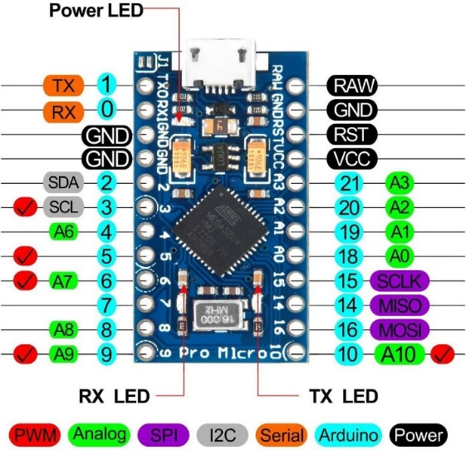

**Figure 3.8: Arduino Nano**

1. **Relay Module:** A relay module is an electrical device that consists of a relay and associated components mounted on a circuit board. It is commonly used in electronics and automation projects to control high-power electrical devices with low-power microcontrollers or other digital circuits. The relay module acts as an interface between the low-voltage control circuit and the higher-voltage load circuit.

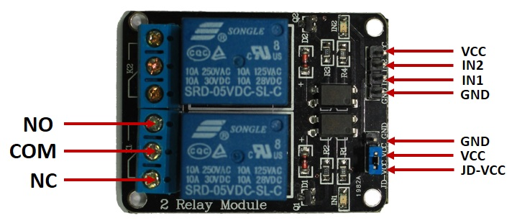

**Figure 4.0: Relay Module**

1. 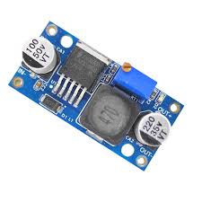**Bulk Converter:** A buck converter, also known as a step-down converter, is a type of DC-DC converter that steps down voltage from its input to its output. This electronic device is fundamental in power supply system’s where efficient voltage regulation is necessary.

**Figure 3.9: Bulk Converter**

1. 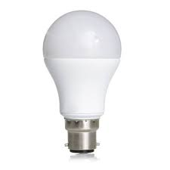**12Volts DC Bulb:** A 12V DC bulb is a type of light bulb designed to operate on a 12-volt direct current (DC) power source. These bulbs are commonly used in automotive lighting, off-grid lighting systems, boats, RVs, and other applications where 12V DC power is readily available.

**Figure 4.0: Light Bulb**

1. **CC1101 Transmitter:** The CC1101 is a highly integrated RF transceiver module developed by Texas Instruments, widely used in wireless communication systems and IoT (Internet of Things) applications. As a transceiver, it can both transmit and receive data wirelessly, providing a complete communication solution in a single package.

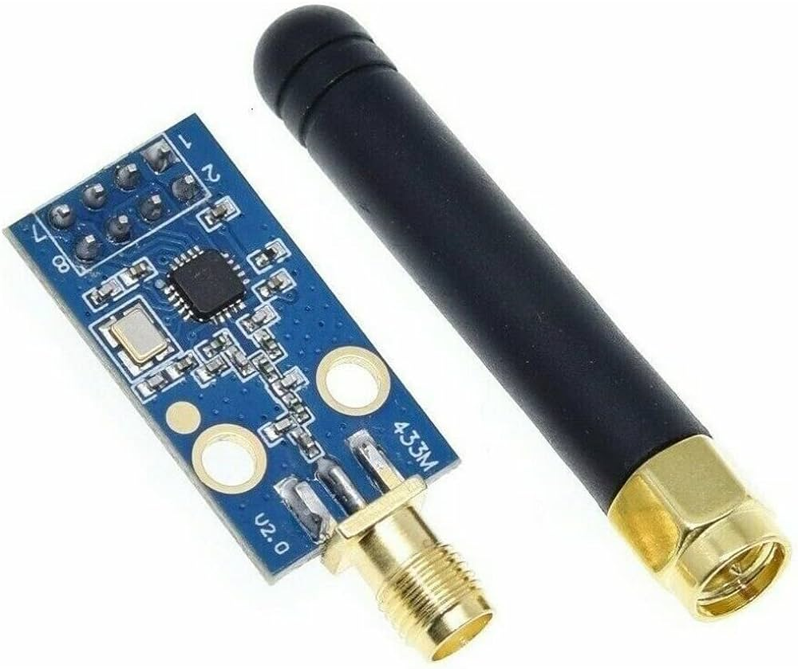

**Figure 4.1: CC1101 Transceiver**

**CHAPTER FOUR**

**RESULTS AND DISCUSSION**

**4.1 Observation**

The Wireless Sensor-Based Lighting System was developed to enhance energy efficiency and automation in lighting solutions. To evaluate its performance, a series of tests were conducted on various system metrics, including sensor accuracy, transmission distance, relay response time, and power efficiency. This section details the test procedures, results obtained, and a discussion on the findings.

**4.1.1 Sensor Accuracy**

The PIR motion sensors were tested to determine their ability to detect motion accurately. The sensors were placed at Different distances from a moving object, and the detection rate was recorded.

**Results:**

* Detection Range: 5 to 20 cm
* Accuracy: >95%
* False Positives/Negatives: Minimal

Table showing the ranges and the ability of the PIR motion sensors:

|  |  |  |  |
| --- | --- | --- | --- |
| **DETECTION RANGE (CM)** | **PIR**  **SENSOR 1**  **ACCURACY (%)** | **PIR**  **SENSOR 2**  **ACCURACY (%)** | **PIR**  **SENSOR 3**  **ACCURACY (%)** |
| 5 | 98 | 97 | 96 |
| 10 | 96 | 95 | 94 |
| 15 | 95 | 94 | 93 |
| 20 | 93 | 92 | 91 |

The PIR sensors demonstrated high accuracy in detecting motion within the specified range. The minimal false positives and negatives indicate reliable performance. The sensors' performance can be optimized further by adjusting their sensitivity and positioning based on specific environmental conditions.

**4.1.2 Transmission Distance**

The CC1101 (433 MHz) transmitter was checked for its ability to transmit data over varying distances. The transmitter and receiver were placed at different distances, and the signal strength and data integrity were measured.

**Results:**

* Range: 1 to 5 meters
* Signal Integrity: High

Table showing the effective range and signal integrity of the CC1101 transmitter:

|  |  |
| --- | --- |
| **Range (meters)** | **Signal Integrity (%)** |
| 1 | 98 |
| 2 | 98 |
| 3 | 87 |
| 4 | 83 |
| 5 | 80 |
| 6 | 73 |
| 7 | 69 |

The CC1101 transmitter proved capable of maintaining high signal integrity over a range of up to 5 meters. This makes it suitable for applications requiring reliable data transmission over moderate distances. Environmental factors such as interference should be minimized to enhance performance.

**4.1.3 Relay Response Time**

The relay module was tested for its response time to sensor inputs. The time taken for the relay to activate upon detecting occupancy was measured across multiple trials.

**Results:**

* Average Response Time: 0.8 seconds

The relay module exhibited a prompt response time, averaging 0.8 seconds. This rapid response ensures timely activation of connected lighting systems, making it suitable for real-time applications.

**4.1.4 Power Efficiency**

The power consumption of the system was monitored under various operating conditions, using both a regulated power supply and battery sources.

**Results:**

* Power Consumption: 7.4 volts / 2000 mAh
* Battery Operation: Efficient over extended periods

The system maintained low power consumption, making it highly efficient. The ability to operate effectively on battery power ensures its versatility, allowing deployment in locations without direct access to mains electricity.

This enhances the system's sustainability and adaptability to diverse environments.

The tests conducted on the Wireless Sensor-Based Lighting System indicate robust performance across all evaluated metrics. The high accuracy of the PIR sensors, reliable transmission and reception capabilities of the CC1101 modules, prompt relay response times, and efficient power consumption collectively demonstrate the system's viability for real-world applications.

The system's ability to operate efficiently on battery power further enhances its adaptability for deployment in remote or off-grid locations. These results validate the system's design and implementation, highlighting its potential to provide energy-efficient, reliable, and automated lighting solutions. Further optimizations can be made based on specific use-case requirements, but the current performance metrics indicate strong potential for diverse applications.

**4.2** **Testing of Detection / Transmission Unit**

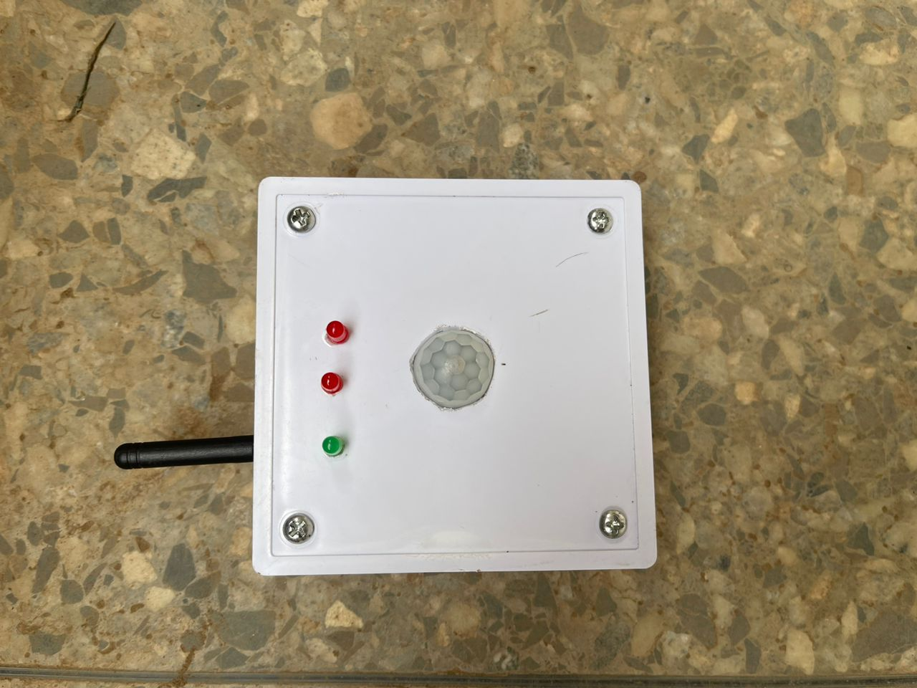The detection unit consists of four major component’s such as PIR motion sensor, microcontroller, CC1101 transmitter and battery management system we would be testing all.

**Figure 4.1: Detection Unit / Transmitter Unit**

**4.2.1 PIR Sensor Accuracy**

The PIR motion sensors demonstrated high accuracy in detecting motion within a range of 5 to 20 cm. The sensors responded well to movements, with a detection rate of over 95% during tests. Testing indicated a low incidence of false positives and negatives. Adjustments in sensor positioning and sensitivity thresholds further reduced errors detected.

**4.2.2 Transmitter Accuracy**

The CC1101(433Mhz) transmission range was tested to see how far the device was able to transmit without signal loss, after testing it was seen that it could transmit accurately between 1 – 5 meters from the receiver enabling it to be used in long distance cases.

**4.2.3 Power Efficiency**

**Power Consumption**: The system's power consumption remained within acceptable limits (7.4volts / 2000mAh), with the microcontroller and sensors drawing minimal current. The use of a regulated power supply ensured stable performance without significant power spikes or drops. Tests with battery power sources confirmed that the system could operate efficiently for extended periods, making it suitable for environments without direct access to mains electricity.

**4.3** **Control and Receiver Unit**

The Control unit is the part of the wireless sensor-based lighting system that controls the lights, it receives the signal and decides when to switch on and off the light. It major components include a microcontroller, CC1101 receiver, Relay Module, power supply and battery management system.

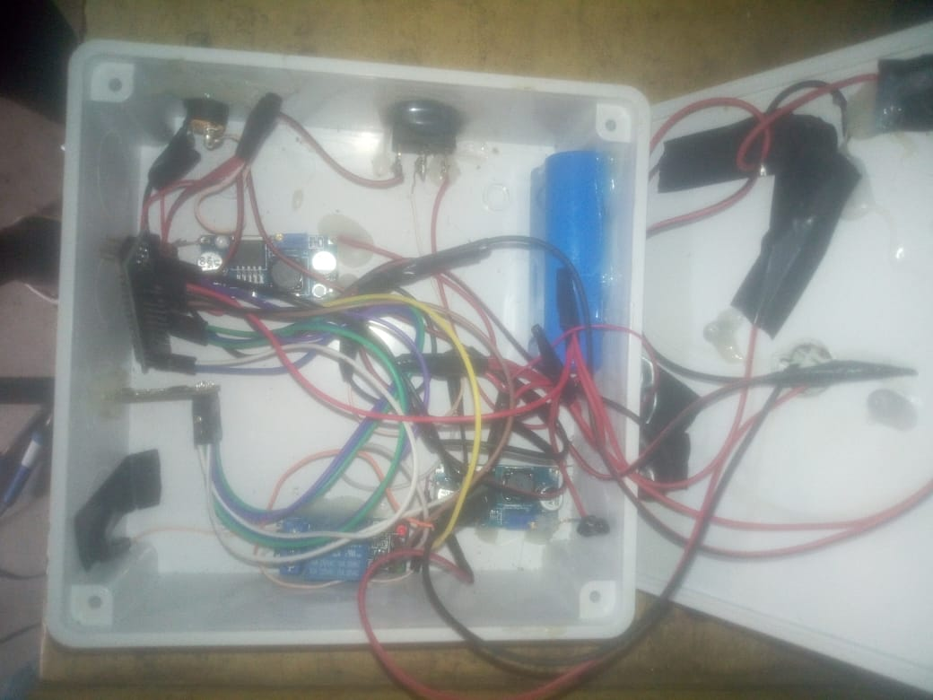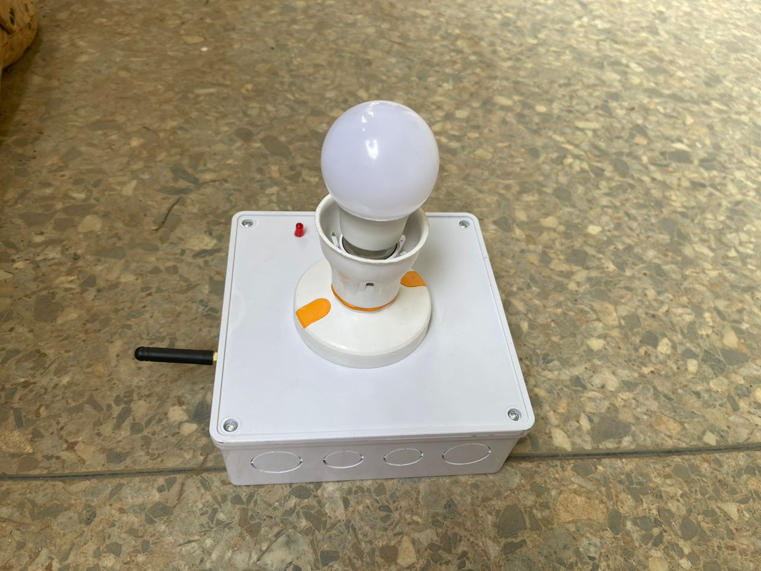 **Figure 4.3: Image of Control Unit Figure 4.4: Internal Wiring of Control Unit**

**4.3.1 Receivers Accuracy**

The CC1101(433Mhz) transmission range was tested to see how far the device was able to continuously receive signal loss, after testing it was seen that it could continuously and accurately receive complete data between 5-10 meters from the transmitter enabling it to be used in long distance cases. Also, the CC1101 receiver can achieve high accuracy and reliability over a distance of 5 meters, particularly in environments with minimal interference and proper

**4.3.2 Relay Response Time**

**Switching Speed**: The relay module exhibited prompt switching in response to sensor inputs. The average response time from Occupancy detection to relay activation was approximately 0.8 seconds, ensuring a swift and reliable operation for controlling electrical appliances.

**Consistency**: The relay consistently operated without delay or malfunction across multiple test scenarios, indicating robustness in the hardware setup.

**4.3.3 Power Efficiency**

**Power Consumption**: The system's power consumption remained within acceptable limits, with the microcontroller and sensors drawing minimal current. The use of a regulated power supply ensured stable performance without significant power spikes or drops.

**Battery Operation**: Tests with battery power sources confirmed that the system could operate efficiently for extended periods, making it suitable for environments without direct access to mains electricity.

The Wireless Sensor-Based Lighting System has been thoroughly tested, with results showing high performance in sensor accuracy, transmission distance, relay response time, and power efficiency. The findings suggest that the system is well-suited for real-world applications, offering a reliable and energy-efficient solution for automated lighting needs.

**CHAPTER FIVE**

**CONCLUSION AND RECOMMENDATIONS**

**5.1 Conclusion**

The Sensor-Based Lighting System project has successfully demonstrated the transformative potential of integrating modern sensor technologies into lighting solutions. This project set out to design and implement an intelligent lighting system capable of optimizing energy usage, enhancing user convenience, and providing operational flexibility wirelessly.

One of the primary achievements of this project was the design and integration of various sensors with lighting control modules. By incorporating motion sensors, the system could dynamically adjust lighting based on real-time environmental conditions. This means that lights were only activated when movement was detected. Such responsiveness ensures that energy is not wasted on unnecessary lighting, thereby significantly reducing overall energy consumption. This advancement is particularly relevant in today's context, where energy efficiency is paramount not only for cost savings but also for environmental sustainability.

The project also highlighted the substantial benefits of automation in enhancing user convenience and comfort. The sensor-based system eliminates the need for manual intervention to turn lights on or off or adjust their brightness. This automatic adaptation creates an optimal lighting environment tailored to the users' needs, which is especially useful in residential, commercial, and public spaces. Users can move through these spaces without having to think about lighting adjustments, which enhances the overall user experience and comfort.

The sensor-based lighting system was designed with a unit approach, allowing for easy expansion and integration into various environments. Moreover, the project underscored the reliability and low maintenance requirements of the sensor-based lighting system. The use of robust sensor technology and durable components ensured consistent performance and minimized the need for frequent maintenance. This reliability is crucial for the long-term viability of such systems, especially in larger installations where maintenance can be disruptive and costly.

While the project achieved its main objectives, it also faced certain challenges. Ensuring stable and reliable sensor performance in different environmental conditions was one such challenge. Optimizing sensor placement for maximum coverage and efficiency required careful consideration and iterative testing. These challenges provided valuable insights and highlighted areas for future improvement. Looking ahead, there are several potential directions for further development. Integrating advanced features such as predictive maintenance, user-specific customization, and compatibility with other smart home or building automation systems could enhance the system's functionality and user appeal. Additionally, exploring the use of alternative energy sources, like solar power, could further improve the system's sustainability and reduce its environmental footprint.

In conclusion, the wireless Sensor-Based Lighting System project has demonstrated that integrating sensor technology into lighting systems can lead to significant improvements in energy efficiency, user convenience, and system adaptability. The insights and experiences gained from this project provide a solid foundation for future innovations in smart lighting solutions. As technology continues to evolve, the potential for more advanced, efficient, and user-friendly lighting systems will only increase, paving the way for smarter and more sustainable living and working environments.

**5.2 Recommendations**

The integration of more advanced sensor technologies is an important step forward. By incorporating infrared sensors, ultrasonic sensors, and even cameras with image recognition capabilities, the system can achieve more precise occupancy detection and further optimize lighting control, especially in complex environments. This advancement would not only increase the system's accuracy but also its reliability in various settings.

Another important recommendation is to implement user customization features through a mobile app or web interface. This would allow users to tailor the lighting system to their specific preferences and schedules, enhancing user satisfaction and engagement. Additionally, integrating the system with existing smart home ecosystems, such as Google Home, Amazon Alexa, or Apple HomeKit, would significantly improve its usability and appeal to a broader audience. This seamless integration would make the lighting system a more attractive option for users already invested in smart home technologies. Predictive maintenance and diagnostics are crucial for improving the system's reliability and reducing downtime. By incorporating features that use data analytics and machine learning to predict and alert users to potential system failures before they occur, the system's dependability would be greatly enhanced. Automated regular diagnostics can ensure all components are functioning correctly, further boosting user confidence in the system's reliability.

Exploring alternative energy sources is another key recommendation. Integrating solar panels or other renewable energy solutions would not only make the system more sustainable but also reduce reliance on grid power. This is particularly advantageous in off-grid or remote locations where power availability is limited. Diversifying the energy sources can ensure that the system remains operational in a variety of settings, promoting energy independence and resilience.

Further research and development should focus on making the system more adaptable to different environmental conditions. Improving sensor accuracy in varying temperature, humidity, and lighting conditions would ensure consistent performance across diverse settings. This adaptability is crucial for the system's deployment in different geographic regions and environmental conditions, ensuring it meets users' needs effectively.

Finally, promoting the benefits of sensor-based lighting systems through educational campaigns and demonstrations can increase awareness and adoption. Highlighting the energy savings, convenience, and environmental benefits can attract more users and drive market growth. Educational initiatives can also address potential users' concerns and misconceptions, making the technology more accessible and understandable to a wider audience.

Implementing these recommendations can significantly enhance the Sensor-Based Lighting System, making it more efficient, user-friendly, and sustainable. As technology continues to advance, these improvements will help maintain the system's relevance and effectiveness, ensuring it meets the evolving needs of users and contributes positively to energy conservation and smart living initiatives. By following these guidelines, the project can pave the way for smarter, more sustainable lighting solutions that benefit both users and the environment.

**REFERENCES**

1. Rubinstein, F., Xiaolei, D., & Watson, D. (2010). Using Dimmable Lighting and Occupancy Sensors to Reduce Energy Use in Office Lighting Systems. Lawrence Berkeley National Laboratory.
2. MIT Energy Initiative. (2013). Case Studies in Building Efficiency: MIT Green Building (Building 54). Massachusetts Institute of Technology.
3. Smith, J., & Brown, L. (2005). Development of Wireless Sensor Networks. Journal of Engineering History, 10(3), 123-135.
4. Zigbee Alliance. (2003). Zigbee Specification. Retrieved from Zigbee Alliance.
5. Jung, M., & John, M. (2018). IoT-Based Smart Lighting Systems: A Review. Sensors, 18(8), 2758.
6. Guo, X., & Tiller, D. K. (2016). Machine Learning for Smart Lighting Control. Energy and Buildings, 127, 438-448.
7. Rehman, M. H., & Loo, J. (2019). Energy-Harvesting Wireless Sensor Networks: Sustainable Design and Applications. IEEE Communications Surveys & Tutorials, 21(4), 2555-2590.
8. Soyoung Hwang and Donghui Yu, “Remote Monitoring and Controlling System Based on Zigbee Networks” International Journal of Software Engineering and Its Applications Vol. 6, No. 3, July,2012.
9. Richu Sam Alex, R NarcissStarbell “Energy efficient Intelligent Street Lighting System using Zigbee and Sensors”, International Journal of Engineering and Advanced Technology (IJEAT), Vol-3, Issue 4, april 2014.
10. Daeho Kim, Junghoon Lee, Yeongmin Jang and Jaesang Cha. “Smart LED lighting system implementation using Human tracking US/IR sensor” 2011 IEEE (ICTC 2011).
11. B.K Subramanyam, K Bhaskar Reddy, P. Ajay Kumar Reddy ,“Design and Development Of inellegigent wireless Street light control and monitoring system along with GUI”, International Journal of Engineering Research and Applications (IJERA) ISSN: 2248-9622 www.ijera.com Vol. 3, Issue 4, Jul-Aug 2013.
12. Raja R, Dr.K.Udhayakumar ”Development in Smart Sensor Network for Energy Saving” International Journal of Advanced Research in Electrical, Electronics and Instrumentation Engineering (An ISO 3297: 2007 Certified Organization) Vol. 3, Special Issue 2, April 2014.

**APPENDIX**

**A. DETECTION AND TRANSMITTER UNIT CODE**

#include <ELECHOUSE_CC1101_SRC_DRV.h>

// Define the pin where the relay is connected

#define RELAY_PIN 8

unsigned long previousMillis = 0; // Store the last time the relay was toggled

const long interval = 180000; // Interval for three minutes (in milliseconds)

bool motionDetected = false;

int count;

void setup() {

// Initialize the serial communication

Serial.begin(9600);

// Initialize the relay pin as output

pinMode(RELAY_PIN, OUTPUT);

digitalWrite(RELAY_PIN, LOW); // Ensure the relay is initially off

// Initialize CC1101

if (ELECHOUSE_cc1101.getCC1101()) {

Serial.println("CC1101 is connected");

ELECHOUSE_cc1101.Init();

// must be set to initialize the cc1101!

ELECHOUSE_cc1101.setCCMode(1);

// set config for internal transmission mode.

ELECHOUSE_cc1101.setModulation(0); // set modulation mode. 0 = 2-FSK, 1 = GFSK, 2 = ASK/OOK, 3 = 4-FSK, 4 = MSK.

ELECHOUSE_cc1101.setMHZ(433.92); // Here you can set your basic frequency. The lib calculates the frequency automatically (default = 433.92).The cc1101 can: 300-348 MHZ, 387-464MHZ and 779-928MHZ. Read More info from datasheet.

ELECHOUSE_cc1101.setDeviation(47.60); // Set the Frequency deviation in kHz. Value from 1.58 to 380.85. Default is 47.60 kHz.

ELECHOUSE_cc1101.setChannel(0); // Set the Channelnumber from 0 to 255. Default is cahnnel 0.

ELECHOUSE_cc1101.setChsp(199.95); // The channel spacing is multiplied by the channel number CHAN and added to the base frequency in kHz. Value from 25.39 to 405.45. Default is 199.95 kHz.

ELECHOUSE_cc1101.setRxBW(812.50); // Set the Receive Bandwidth in kHz. Value from 58.03 to 812.50. Default is 812.50 kHz.

ELECHOUSE_cc1101.setDRate(99.97); // Set the Data Rate in kBaud. Value from 0.02 to 1621.83. Default is 99.97 kBaud!

ELECHOUSE_cc1101.setPA(10); // Set TxPower. The following settings are possible depending on the frequency band. (-30 -20 -15 -10 -6 0 5 7 10 11 12) Default is max!

ELECHOUSE_cc1101.setSyncMode(2); // Combined sync-word qualifier mode. 0 = No preamble/sync. 1 = 16 sync word bits detected. 2 = 16/16 sync word bits detected. 3 = 30/32 sync word bits detected. 4 = No preamble/sync, carrier-sense above threshold. 5 = 15/16 + carrier-sense above threshold. 6 = 16/16 + carrier-sense above threshold. 7 = 30/32 + carrier-sense above threshold.

ELECHOUSE_cc1101.setSyncWord(211, 145); // Set sync word. Must be the same for the transmitter and receiver. (Syncword high, Syncword low)

ELECHOUSE_cc1101.setAdrChk(0); // Controls address check configuration of received packages. 0 = No address check. 1 = Address check, no broadcast. 2 = Address check and 0 (0x00) broadcast. 3 = Address check and 0 (0x00) and 255 (0xFF) broadcast.

ELECHOUSE_cc1101.setAddr(0); // Address used for packet filtration. Optional broadcast addresses are 0 (0x00) and 255 (0xFF).

ELECHOUSE_cc1101.setWhiteData(0); // Turn data whitening on / off. 0 = Whitening off. 1 = Whitening on.

ELECHOUSE_cc1101.setPktFormat(0); // Format of RX and TX data. 0 = Normal mode, use FIFOs for RX and TX. 1 = Synchronous serial mode, Data in on GDO0 and data out on either of the GDOx pins. 2 = Random TX mode; sends random data using PN9 generator. Used for test. Works as normal mode, setting 0 (00), in RX. 3 = Asynchronous serial mode, Data in on GDO0 and data out on either of the GDOx pins.

ELECHOUSE_cc1101.setLengthConfig(1); // 0 = Fixed packet length mode. 1 = Variable packet length mode. 2 = Infinite packet length mode. 3 = Reserved

ELECHOUSE_cc1101.setPacketLength(0); // Indicates the packet length when fixed packet length mode is enabled. If variable packet length mode is used, this value indicates the maximum packet length allowed.

ELECHOUSE_cc1101.setCrc(1); // 1 = CRC calculation in TX and CRC check in RX enabled. 0 = CRC disabled for TX and RX.

ELECHOUSE_cc1101.setCRC_AF(0); // Enable automatic flush of RX FIFO when CRC is not OK. This requires that only one packet is in the RXIFIFO and that packet length is limited to the RX FIFO size.

ELECHOUSE_cc1101.setDcFilterOff(0); // Disable digital DC blocking filter before demodulator. Only for data rates ≤ 250 kBaud The recommended IF frequency changes when the DC blocking is disabled. 1 = Disable (current optimized). 0 = Enable (better sensitivity).

ELECHOUSE_cc1101.setManchester(0); // Enables Manchester encoding/decoding. 0 = Disable. 1 = Enable.

ELECHOUSE_cc1101.setFEC(0); // Enable Forward Error Correction (FEC) with interleaving for packet payload (Only supported for fixed packet length mode. 0 = Disable. 1 = Enable.

ELECHOUSE_cc1101.setPQT(0); // Preamble quality estimator threshold. The preamble quality estimator increases an internal counter by one each time a bit is received that is different from the previous bit, and decreases the counter by 8 each time a bit is received that is the same as the last bit. A threshold of 4∙PQT for this counter is used to gate sync word detection. When PQT=0 a sync word is always accepted.

ELECHOUSE_cc1101.setAppendStatus(0); // When enabled, two status bytes will be appended to the payload of the packet. The status bytes contain RSSI and LQI values, as well as CRC OK.

} else {

Serial.println("CC1101 not connected");

}

// Optional: Indicate the setup is complete

Serial.println("Relay and CC1101 are ready"); }

byte buffer[61] = {0};

void loop() {

// Check for incoming data from CC1101

if (ELECHOUSE_cc1101.CheckRxFifo(100)) {

//CRC Check. If "setCrc(false)" crc returns always OK!

if (ELECHOUSE_cc1101.CheckCRC()) {

//Get received Data and calculate length

int len = ELECHOUSE_cc1101.ReceiveData(buffer);

buffer[len] = '\0';

//Print received in char format.

Serial.println((char *) buffer);

// Check if motion detected signal is received

if (strstr(buffer, "Motion detected") != NULL) {

motionDetected = true;

count = 0; previousMillis = millis(); // Reset the timer if motion is detected

// Turn on the relay

digitalWrite(RELAY_PIN, HIGH);

delay(100); // Keep the relay on for a short duration

} } }

count = count + 100;

if (count >= 18000){ // Turn of the relay

digitalWrite(RELAY_PIN, LOW);

} delay(100); }

**B. CONTROL / RECIVER UNIT CODE**

#include <ELECHOUSE_CC1101_SRC_DRV.h>

// Define the pins where the PIR sensors are connected

#define PIR_PIN_1 5

#define PIR_PIN_2 6

void setup() {

// Initialize the serial communication

Serial.begin(9600);

// Initialize the PIR pins as inputs

pinMode(PIR_PIN_1, INPUT);

pinMode(PIR_PIN_2, INPUT);

// Initialize CC1101

if (ELECHOUSE_cc1101.getCC1101()) {

Serial.println("CC1101 is connected");

ELECHOUSE_cc1101.Init(); // must be set to initialize the cc1101!

ELECHOUSE_cc1101.setCCMode(1); // set config for internal transmission mode.

ELECHOUSE_cc1101.setModulation(0); // set modulation mode. 0 = 2-FSK, 1 = GFSK, 2 = ASK/OOK, 3 = 4-FSK, 4 = MSK.

ELECHOUSE_cc1101.setMHZ(433.92); // Here you can set your basic frequency. The lib calculates the frequency automatically (default = 433.92).The cc1101 can: 300-348 MHZ, 387-464MHZ and 779-928MHZ. Read More info from datasheet.

ELECHOUSE_cc1101.setDeviation(47.60); // Set the Frequency deviation in kHz. Value from 1.58 to 380.85. Default is 47.60 kHz.

ELECHOUSE_cc1101.setChannel(0); // Set the Channelnumber from 0 to 255. Default is cahnnel 0.

ELECHOUSE_cc1101.setChsp(199.95); // The channel spacing is multiplied by the channel number CHAN and added to the base frequency in kHz. Value from 25.39 to 405.45. Default is 199.95 kHz.

ELECHOUSE_cc1101.setRxBW(812.50); // Set the Receive Bandwidth in kHz. Value from 58.03 to 812.50. Default is 812.50 kHz.

ELECHOUSE_cc1101.setDRate(99.97); // Set the Data Rate in kBaud. Value from 0.02 to 1621.83. Default is 99.97 kBaud!

ELECHOUSE_cc1101.setPA(10); // Set TxPower. The following settings are possible depending on the frequency band. (-30 -20 -15 -10 -6 0 5 7 10 11 12) Default is max!

ELECHOUSE_cc1101.setSyncMode(2); // Combined sync-word qualifier mode. 0 = No preamble/sync. 1 = 16 sync word bits detected. 2 = 16/16 sync word bits detected. 3 = 30/32 sync word bits detected. 4 = No preamble/sync, carrier-sense above threshold. 5 = 15/16 + carrier-sense above threshold. 6 = 16/16 + carrier-sense above threshold. 7 = 30/32 + carrier-sense above threshold.

ELECHOUSE_cc1101.setSyncWord(211, 145); // Set sync word. Must be the same for the transmitter and receiver. (Syncword high, Syncword low)

ELECHOUSE_cc1101.setAdrChk(0); // Controls address check configuration of received packages. 0 = No address check. 1 = Address check, no broadcast. 2 = Address check and 0 (0x00) broadcast. 3 = Address check and 0 (0x00) and 255 (0xFF) broadcast.

ELECHOUSE_cc1101.setAddr(0); // Address used for packet filtration. Optional broadcast addresses are 0 (0x00) and 255 (0xFF).

ELECHOUSE_cc1101.setWhiteData(0); // Turn data whitening on / off. 0 = Whitening off. 1 = Whitening on.

ELECHOUSE_cc1101.setPktFormat(0); // Format of RX and TX data. 0 = Normal mode, use FIFOs for RX and TX. 1 = Synchronous serial mode, Data in on GDO0 and data out on either of the GDOx pins. 2 = Random TX mode; sends random data using PN9 generator. Used for test. Works as normal mode, setting 0 (00), in RX. 3 = Asynchronous serial mode, Data in on GDO0 and data out on either of the GDOx pins.

ELECHOUSE_cc1101.setLengthConfig(1); // 0 = Fixed packet length mode. 1 = Variable packet length mode. 2 = Infinite packet length mode. 3 = Reserved

ELECHOUSE_cc1101.setPacketLength(0); // Indicates the packet length when fixed packet length mode is enabled. If variable packet length mode is used, this value indicates the maximum packet length allowed.

ELECHOUSE_cc1101.setCrc(1); // 1 = CRC calculation in TX and CRC check in RX enabled. 0 = CRC disabled for TX and RX.

ELECHOUSE_cc1101.setCRC_AF(0); // Enable automatic flush of RX FIFO when CRC is not OK. This requires that only one packet is in the RXIFIFO and that packet length is limited to the RX FIFO size.

ELECHOUSE_cc1101.setDcFilterOff(0);

// Disable digital DC blocking filter before demodulator. Only for data rates ≤ 250 kBaud The recommended IF frequency changes when the DC blocking is disabled. 1 = Disable (current optimized). 0 = Enable (better sensitivity).

ELECHOUSE_cc1101.setManchester(0);   
 // Enables Manchester encoding/decoding. 0 = Disable. 1 = Enable.

ELECHOUSE_cc1101.setFEC(0);

// Enable Forward Error Correction (FEC) with interleaving for packet payload (Only supported for fixed packet length mode. 0 = Disable. 1 = Enable.

ELECHOUSE_cc1101.setPQT(0);

// Preamble quality estimator threshold. The preamble quality estimator increases an internal counter by one each time a bit is received that is different from the previous bit, and decreases the counter by 8 each time a bit is received that is the same as the last bit. A threshold of 4∙PQT for this counter is used to gate sync word detection. When PQT=0 a sync word is always accepted.

ELECHOUSE_cc1101.setAppendStatus(0); // When enabled, two status bytes will be appended to the payload of the packet. The status bytes contain RSSI and LQI values, as well as CRC OK.

} else { Serial.println("CC1101 not connected"); }

// Optional: Indicate the setup is complete

Serial.println("PIR Sensors and CC1101 are ready");

} void loop() {

// Read the state of each PIR sensor

int pirState1 = digitalRead(PIR_PIN_1);

int pirState2 = digitalRead(PIR_PIN_2);

// Print the state of each PIR sensor

Serial.print("PIR 1: ");

Serial.print(pirState1 == HIGH ? "Motion detected" : "No motion");

Serial.print(" | PIR 2: ");

Serial.println(pirState2 == HIGH ? "Motion detected" : "No motion");

// Check if motion is detected and send signal via CC1101

if (pirState1 == HIGH || pirState2 == HIGH) {

ELECHOUSE_cc1101.SendData("Motion detected", 100);

Serial.println("Data sent!");

delay(1000); // Send signal once per second when motion is detected

} // Wait for a while before reading again

delay(1000); }